CENTRAL AFRICA:
HIDDEN AGENDAS & THE WESTERN PRESS

by keith harmon snow

Writer’s note: This article appeared on January 4, 2001, in The Voice News of Winstead, CT (www.thevoicenews.com). It was one of two on Central Africa authored by keith harmon snow that was selected by Project Censored in 2002 as one of the top 25 most underreported (censored) news stories of 2001-2002; over 900 stories were nominated. It has been updated herein only slightly.

War in Congo alone has claimed over three million lives since 1998 alone.
This war calls to mind the innocent men, women and children fleeing Congo into Uganda whom I met there in 2000. In particular I recall one refugee, David, who explained to me how soldiers tortured him, beat his children and raped his wife. The day I spoke with David his six year-old daughter was dying. The next morning she was dead.

With his family David had fled his home near Bunia, Congo, and for three weeks they ate roots and plants and bugs as they walked through mud and forest and mountains from Congo to Uganda. They had only the clothing on their backs. No money, no food, no security. The ordeal of David’s family defies understanding by people in the United States whom have not witnessed or experienced the suffering. The additional outrage is that people in the United States benefit from the exploitation of this poor family’s land, that people in the US know nothing about it, and that most people seem incapable of caring. The lack of awareness, the mythology of utter hopelessness, and the incapacity to relate to the profound suffering in Africa is a direct result – and a primary intention -- of the mass media.

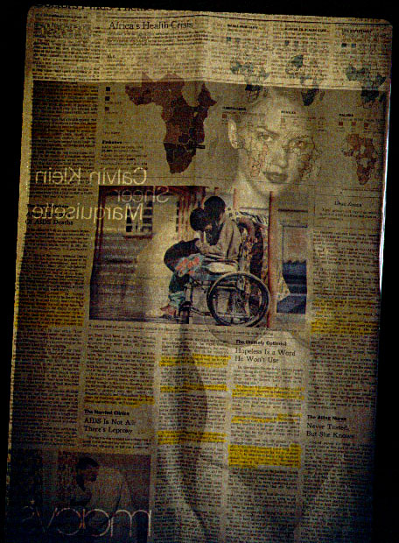

PHOTO KEITH HARMON SNOW: Directors of the New York Times are also directors of Bristol Myers Squibb, a leading manufacturer and peddler of breast implants for women. And that’s not all that’s going on here …. Calvin Klein is owned by Unilever, one of the world’s largest and most secretive corporations, and they operate widely, and with significant but unreported economic, political and military connections in Africa.

In contradistinction however, even as I wrote this article – in August of 2001 -- there was then emerging in the major western media a fresh propaganda front on Congo. That meant that something in the western political economy of warfare had shifted in such a way as to make it expedient to advertise aspects of the brutal war in Congo. And the key word here is “aspects”. September 11th changed that however, and Congo again slipped into media whiteout where it has remained, for the most part, since.

Human Rights Watch published a major report on systematic rape by RPF (Rwandan) and UPDF (Ugandan) soldiers in eastern Congo, but that report of May 2002 was almost totally ignored. Not only does the media ignore the issues of war in Africa, but leftists and peaceniks as well. Suffering in Congo, in fact, and in Africa more generally, is virtually invisible.

The big beneficiaries of war in Central Africa have not been named. The western media will never name them, because directors of western media corporations would have to name themselves.

Propaganda is often true. It is selective information used selectively and expeditiously to serve a certain purpose. On Africa, the media’s aim is to sow racism, apathy, indifference, inaction and – most critical -- a sense of hopelessness in the public mind. This is the coup of the western media. It has succeeded.

While we should perhaps applaud the New York Times and Boston Globe and other major media for finally reporting something on the inhuman conflict in Congo – which is also driving the extinction of the great apes, the deforestation of the vast Congo Basin, and hence global climate mayhem – we must also recognize that the imperatives of corporate profit have insured that four years of western military and economic exploitation of Congo have taken place completely off the radar screen of the American public.

War in Congo has claimed over three million lives since 1998 alone. Innocent civilians have been brutalized, massacred, raped, and tortured by all parties to the conflict. It began with the U.S.-sponsored invasion of Rwanda in 1994, and followed with two subsequent U.S.-sponsored invasions of Congo (1996, 1998). These are not the simple “civil wars” declared by the western press. Even the Rwanda “genocide” (1994) has to some extent been manufactured in the American mind to serve the mythology of tribalism. Meanwhile American green berets and military advisors and Pentagon officials have participated from blackboard to battlefield.

Sierra Leone, Angola, Sudan, Rwanda and Congo/Zaire are wars where factions are armed with U.S. made weapons (M16’s, SAM’s, tanks); where U.S. covert forces undertake brutal secret missions and psychological operations – accountable to no one -- behind the headlines. They are wars where the Central Intelligence Agency is deeply and maliciously entrenched in subverting democracy and orchestrating chaos that is expediently advertised – as such -- by our dubious media. At the roots however, these are wars like any other war.

Essential to the superalloys and weaponry of the global economy of war are Congo’s cobalt, uranium and columbium tantalite (coltan). Cobalt is elemental to nuclear reactors and nuclear weapons, tank armor, industrial furnaces, aerospace, and for 50 years the CIA has insured the free flow of cobalt out of Congo. The human devastation in poverty, disease, torture and massacres is uncountable. Adjectives do not describe the suffering. Similarly, coltan is essential for cellphones and children’s playstations and companies like Sony and Nokia have been cashing in on this windfall – paid in human blood. While the bloody digressions of Japanese Zaibatsu have to some limited extent been exposed by the New York Times -- likely scrambling for corporate leverage and market position -- the greater involvement of powerful Americo-European interests remains obscured.

For example, Royal Dutch/Shell has allied with the Rwandan Patriotic Front, the post-1994 victors both overtly and covertly supported by U.S. military operations and equipment. According to investigative journalist Wayne Madsen (Genocide and Covert Operations in Africa, 1993-1999; Mellen Press), since 1994 Rwanda’s RPF government, headed by Paul Kagame (who was trained at Fort Leavenworth, Kansas) has systematically eliminated upwards of 600,000 people – these a proportion of the International Rescue Committee count of over three million dead since 1998. RPF forces and their Congolese allies have reportedly conscripted prisoners of war for slave labor in mining camps.

When Bill Clinton stated that the U.S. took no action on Rwanda in 1994 because we did not know what was going on at the time, he could not have told a bigger lie. Indeed, the nasty executive underhandedness of Bush and Clinton interests in Africa are meticulously documented in Wayne Madsen’s book.

North American and European multinational corporations are pulling the strings to ensure their cheap and unfettered access to oil, natural gas, gold, diamonds, rubber and timber. In Lake Albert and in the heart of Congo’s forests multinationals are sinking wells for petroleum and natural gas. Shell, Exxon, Chevron, Mobil, Agip, Total-Fina are a few of the petroleum giants controlling the oil fields off the Atlantic coast.
Texaco is entrenched in the Angola and Congo conflicts. Texaco director Charles H. Price is a director of the New York Times Company.

Ditto for Citizen’s Energy International, a firm controlled by the family of Edward Kennedy (D-MA), and by N.Y.-based Lehman Brothers Holdings. Lehman Brother’s director John F. Akers is a director of the New York Times Company. (Lehman Brothers Holdings was based in the World Trade Center in September, 2001.)

Phelps Dodge Corporation has mined Zimbabwe for years and through Zimbabwe is entrenched in the profitable bloodletting in Congo. Long-time Phelps Dodge executive George B. Munroe is a New York Times Company director.

The First Boston (bank) interests of George L. Shinn – a New York Times Company director – certainly influenced selective and slanted New York Times coverage of Zaire/Congo (1996, 1998) relief operations in which First Boston had a huge financial stake.

Taking primary responsibility for planning and implementation of U.S. Special Operations paramilitary forces (read: terrorists) who perpetrated massacres of innocent Congolese civilians throughout 1964 and 1965 was Cyrus Vance, who was then working with Robert McNamara and Dean Rusk, with complete knowledge of President Lyndon Johnson, to implement a covert operation. Vance later became Secretary of State under the Jimmy Carter administration. Perhaps it’s no surprise to learn – since U.S. covert forces have continued to operate in Central Africa wars of late – that Cyrus Vance was one of the directors of the New York Times Company in the 1990s.

Former US President and CIA director George Bush is an advisory board member for Barrick Gold Corporation – which is raping the U.S., Tanzania, Mali, Niger, Canada, Peru and – no surprise -- Congo. Barrick Gold has been operating in the region around Bunia, Congo, the area from which refugees I spoke with had fled. People explained that Barrick gold mining operations near Bunia are secured by Ugandan government troops. The Uganda military also controls gold mines near Bunia, as does an Israeli general paid in gold mining concessions for his military expertise during the first invasion of Zaire/Congo (1996).

Counted among Barrick directors are Brian Mulroney, former Prime Minister of Canada. Another is Edward Neys, former U.S. Ambassador to Canada and chairman of Burson-Marsteller -- one of the world’s largest and most secretive public relations firms.

Burson-Marsteller is a billion-dollar company that covers for organized crime. They are in the business of “perception management” – the latter day term for propaganda. They covered for the Nigerian oil barons and Shell Oil during the Biafran War. They covered for Babcock & Wilcox and the U.S. Nuclear Regulatory Commission as the Three Mile Island nuclear reactor melted down and irradiated the American landscape. They massaged the public and managed their perceptions as the Exxon Valdez supertanker greased the Alaskan wilderness with black crude. Burson-Marsteller covered for Union Carbide after the gas massacre in Bhopal (1984).

Burson-Marsteller has run public relations campaigns to shield extensive, state-orchestrated terror by the “governments” of Argentina, Indonesia, South Korea, Sri Lanka, and Singapore.

That is a short list.

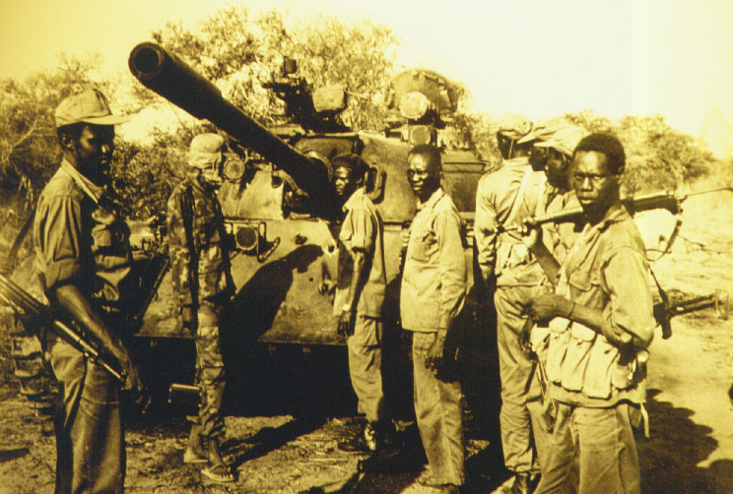

PHOTO COURTESY OF NEW VISION NEWSPAPER KAMPALA UGANDA: The United States is the leading arms supplier to Africa. Sophisticated weapons are only infrequently, and expeditiously, revealed in the Africa reportage of the New York Times. (Wouldn’t want anyone to get the idea that Africa is anything but uncivilized tribals slaughtering each other with spears and machetes.)

Other Barrick Gold directors include J. Trevor Eyton, a member of the Canadian Senate; former U.S. Senator Howard Baker; and the industrious lawyer Vernon E. Jordan, who worked for his good friend then U.S. President Bill Clinton.

Indeed, diamonds are Bill Clinton’s best friend: Throughout his tenure in the White House Clinton personally profited -- at profound human loss of life -- from Congo connections tried and true. For years influential with the brutal Zairean dictator Mobutu Sese-Seko, CIA operative Lawrence Devlin used his Congo network to access diamonds and cobalt for Clintonite diamond kingpins Michael McMurrough, Jean Raymond-Bouelle, Maurice and Leon Templesman, and their companies: America Mineral Fields International (AMFI) – headquartered in Hope Arkansas in 1995 – and Lazare Kaplan International. Unremarkably, AMFI’s mining partners in Africa include Barrick Gold Corporation. (faithful democrats screaming about the “spoiler” vote please take note and consider whom the real spoilers are).

Private military companies and shady intelligence outfits further corporate and private interests. Air Scan International (Florida-based) operates in Sudan and Angola. Others include Executive Outcomes, the Gurkha Security Group, and Military Professional Resources Incorporated (MPRI). MPRI -- run out of Washington D.C. by some 32 retired U.S. generals, like General Ed Soyster -- reportedly advised on the battlefields during the two U.S. sponsored invasions (1996, 1998) of Zaire/Congo. MPRI is also training the Nigerian military, which continues to perpetrate atrocities on innocent civilians living in the oil-producing communities of the Niger River Delta.

(continue below)
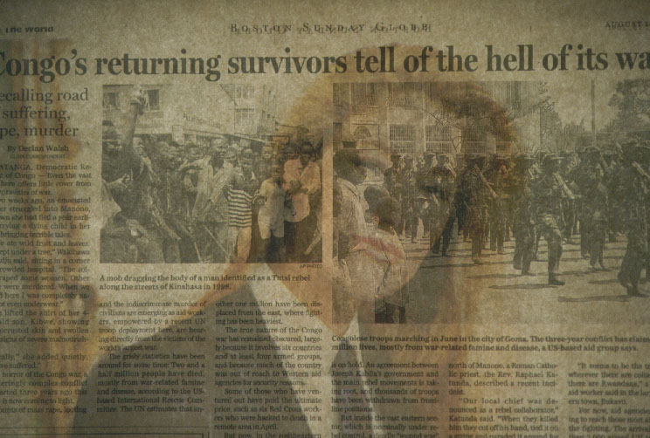

PHOTO: KEITH HARMON SNOW: New York Times reportage on Africa is laced with subliminal seduction.

It is critical that the issues of war and resource capture and media deception on Africa be appreciated, that action be taken immediately to call to account the responsible agents and governments -- whose unconsciousness has brought, and continues to bring, unfathomable suffering, despair and death to an entire continent and hundreds of millions of people. War in Central Africa – Congo and Rwanda -- has claimed at least three to five million lives since 1994. Most of these were innocent men, women and children.

keith harmon snow is a journalist and photographer. In 2000 he spent seven months investigating the conflicts in Angola, Congo, Rwanda and Sudan. In 2001 he presented on a special congressional panel convened by U.S. Congressional Representative Cynthia McKinney to explore the role of US covert forces and private interests in Central Africa. He regularly lectures at colleges and universities on neocolonialism, private profit, and genocide in Africa, and the political economy of the western media.

Leavenworth Papers No 14, Dragon Operations: Hostage Rescues in the Congo, 1964-1965; < http://www-cgsc.army.mil/carl/resources/csi/odom/odom.asp#2-66 >

